Geometry
Chapter 9: Three-Dimensional Figures
9-1: Points, Lines, and Planes in Space
- Point-Line-Plane Postulate
  - Unique Plane Assumption: Through any three noncollinear points there is exactly one plane
  - Intersection Assumption: Two different planes either do not intersect or intersect at exactly one line
- Line-Plane Perpendicular Theorem: If a line is perpendicular to two different lines at their point of intersection, then it is perpendicular to the plane that contains those lines
  - Foot of a segment: the point of intersection of a segment perpendicular to a plane and the plane itself
- Parallel planes are either identical or have no points in common
  - Distance between parallel planes: length of a segment perpendicular to both planes
- Skew Lines: lines that do not intersect and are not in the same plane
- Dihedral angles: the angles that are formed when two planes intersect
  - Edge of dihedral angle: line of intersection of the planes

9-2: Prisms and Cylinders
- Surfaces vs Solids:
  - Surface has two parts: exterior and interior (ex. a balloon)
  - Solid is the union of interior and exterior (ex. bowling ball)

- Parts of a surface
  - Face: a polygonal region
  - Edge: sides of a polygonal region
  - Vertex: vertices of the polygonal region
  - Bases: the region that was translated and its image
  - Lateral surface: the surfaces that aren’t the base
  - Altitude: the perpendicular distance between bases

- Cylinder: cylindrical surface whose base is a circle

- Prism: cylindrical surface whose base is a polygon
  - Regular Prism: prism with regular polygons for bases
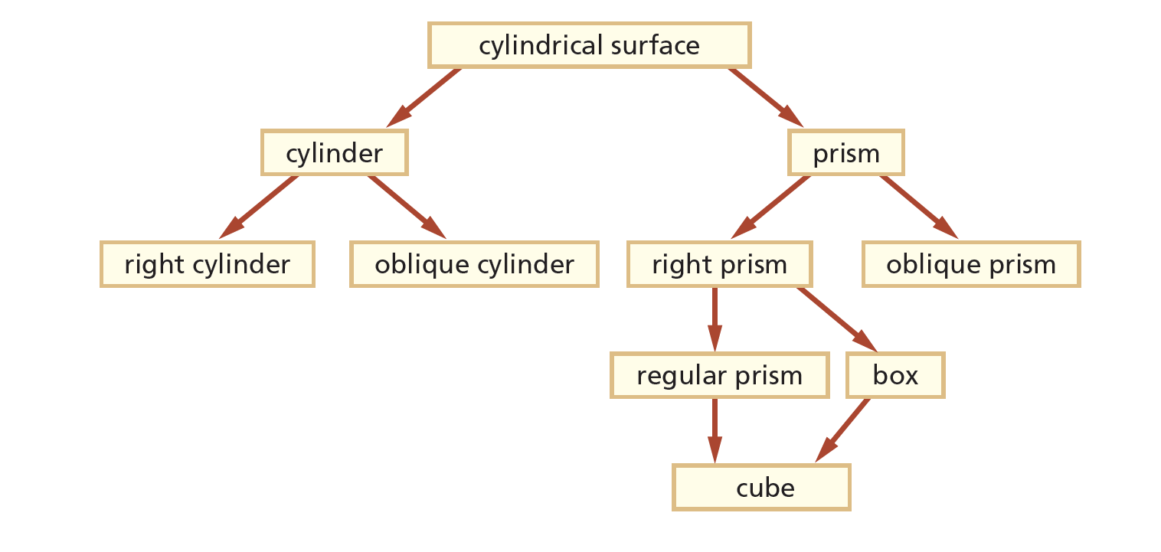

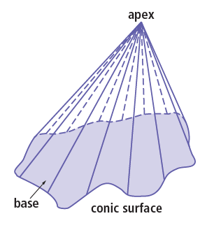
9-3: Pyramids and Cones
- Conic Solid: the set of points between a given point (the apex) and its base

- Pyramid: a conic solid with a convex polygon for its base
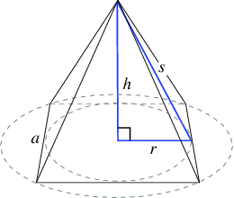
  - Regular pyramid: a pyramid whose base is a regular polygon
  - Right pyramid: a pyramid that has a segment from the apex to the center of the base that is perpendicular to the base
  - Oblique pyramid: a pyramid that is not a right pyramid
- Cone: a conic solid with a circular region for its base
  - Axis of a cone: the line from the apex of a cone to the center of the base
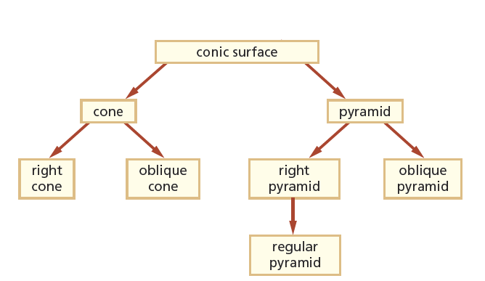

9-4: Drawing in Perspective
- Artists draw in perspective to achieve realism
- Vanishing point: the point at which several lines of a drawing appear to meet
- One-point perspective: a perspective in which there is one vanishing point on the horizon
- Two-point perspective: a perspective in which there are two vanishing points on the horizon

9-5: Views of Solids and Surfaces
- Non-perspective drawings will take a three-dimensional object and represent it in two dimensions

9-6: Spheres and Sections
- Sphere: set of points in space at a certain distance from a point
- Great Circle of a Sphere: the intersection of a plane that contains the center and the sphere
  - The great circle splits the sphere into two hemispheres
- Small Circle of a Sphere: the intersection of a plane that doesn’t contain the center and the sphere.
- Plane Section: intersection of a 3-dimensional figure and a plane

9-7: Reflections in Space
- Reflecting over a plane: the plane is the perpendicular bisector of the segments between every point in the preimage and image
- Figures are congruent if and only if they are the preimage and image under a reflection or composite of reflections
- Reflection Symmetric Figure: a figure that can be divided evenly with a plane

9-8: Making Polyhedra and Other Surfaces
- Polyhedron: 3-dimensional surface that is a union of polygons
- Polyhedra are classified by the number of faces:
  - 4 faces: tetrahedron
  - 6 faces: hexahedron
  - 8 faces: octahedron
  - 12 faces: dodecahedron
  - 20 faces: isosahedron
- Net: a 2-dimensional figure that can be folded to form a 3-dimensional surface

9-9: Surface Areas of Prisms and Cylinders
- Lateral Area (L.A.) = ph
  - p = perimeter of the base
  - h = height of the cylindrical solid
- Surface Area (S.A.) = L.A. + 2B
  - B = area of the base

9-10: Surface Areas of Pyramids and Cones
- L.A. = ½ l p
  - l = slant height
- S.A. = L.A. + B

